

**DATABASE SYSTEM**

**IMPLEMENTATION ON MYSQL**



**FAIQA LATIF (110790)**

IMPLEMENTATION ON MYSQL

* Show databases;

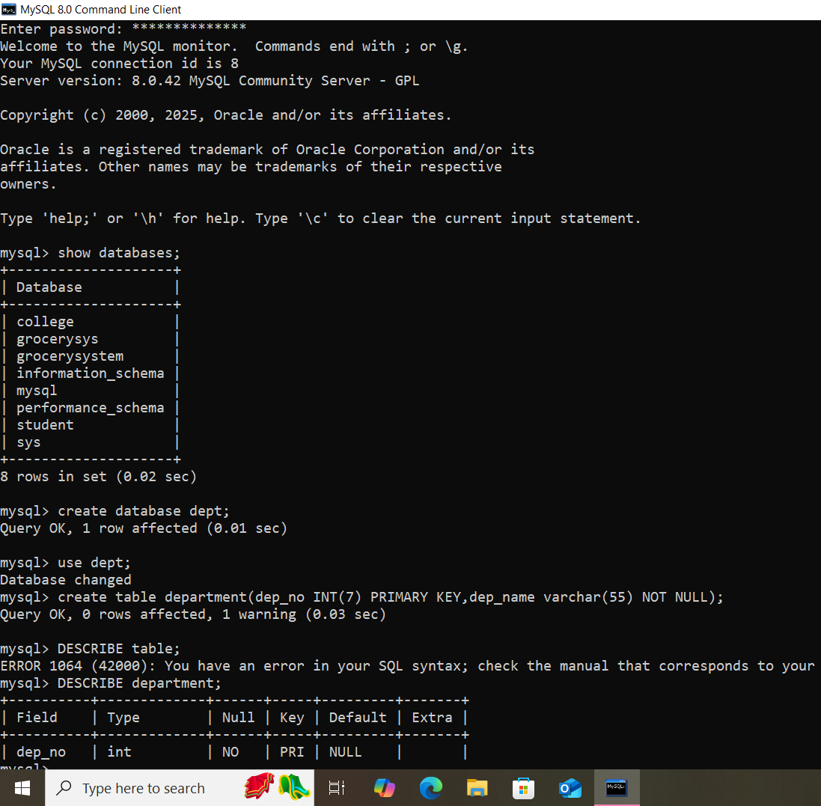

* Create database dept;
* Use dept;
* Create table department:



* DESCRIBE department;
* INSERT INTO department values:
* Select * from department;

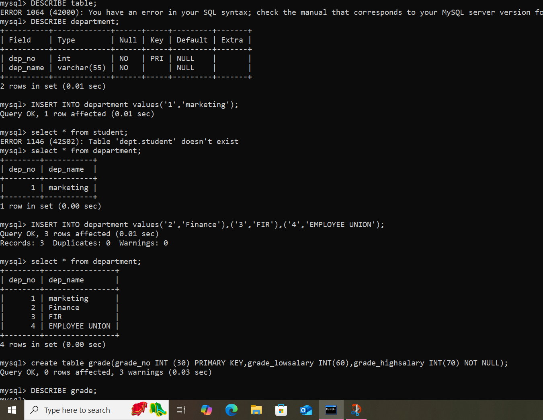

* Create table grade:
* INSERT INTO grade values:
* Select * from grade;

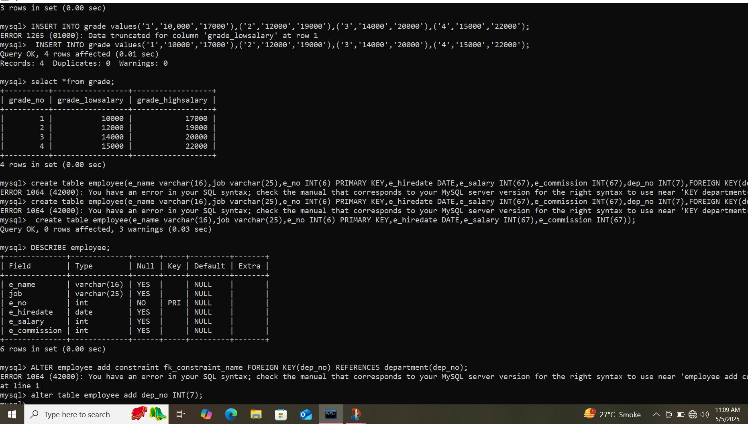

* Create table employee:
* INSERT INTO values:
* Describe employee:



* Add foreign key:
* INSERT INTO employee values:

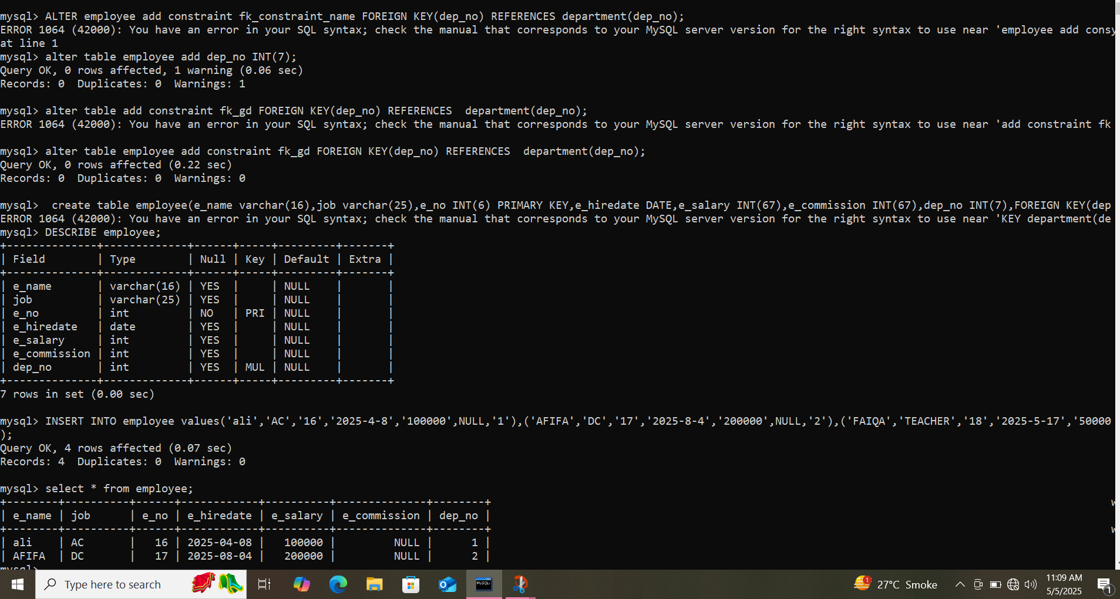

* Select * from employee;

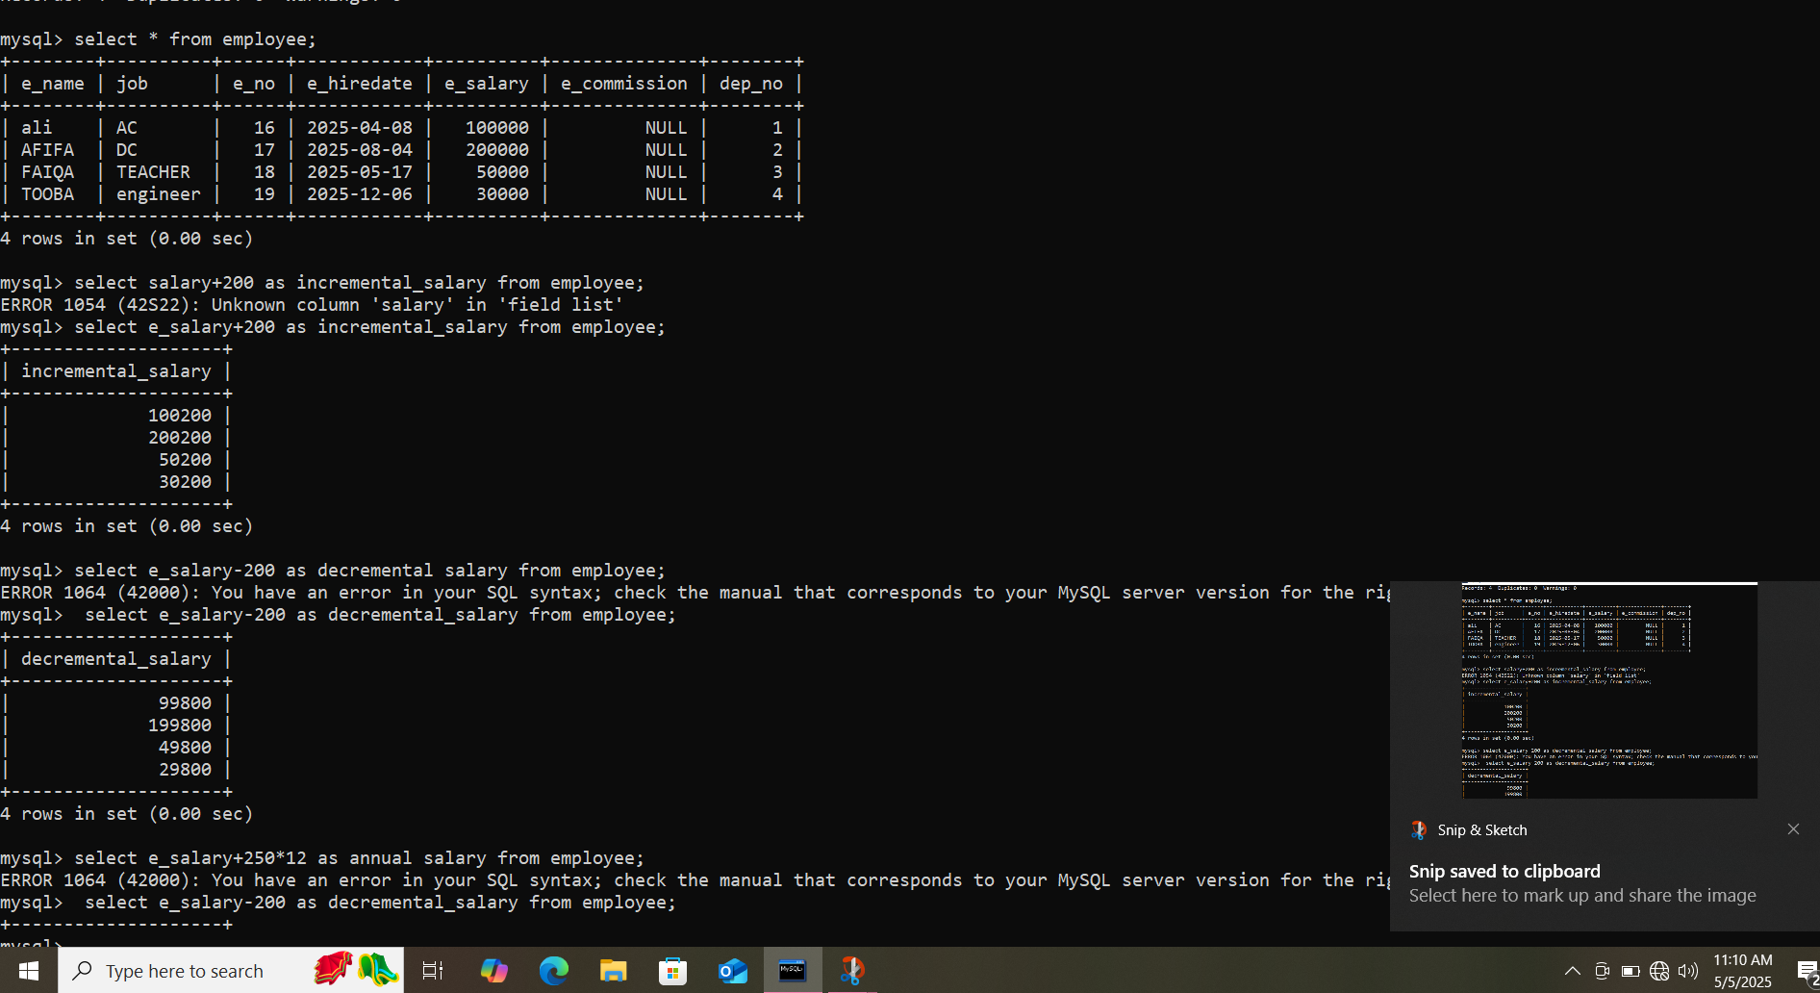

* Apply query for increment in salary



* Apply query for decrement in salary



* Apply query ,in which salary is greater than 1900

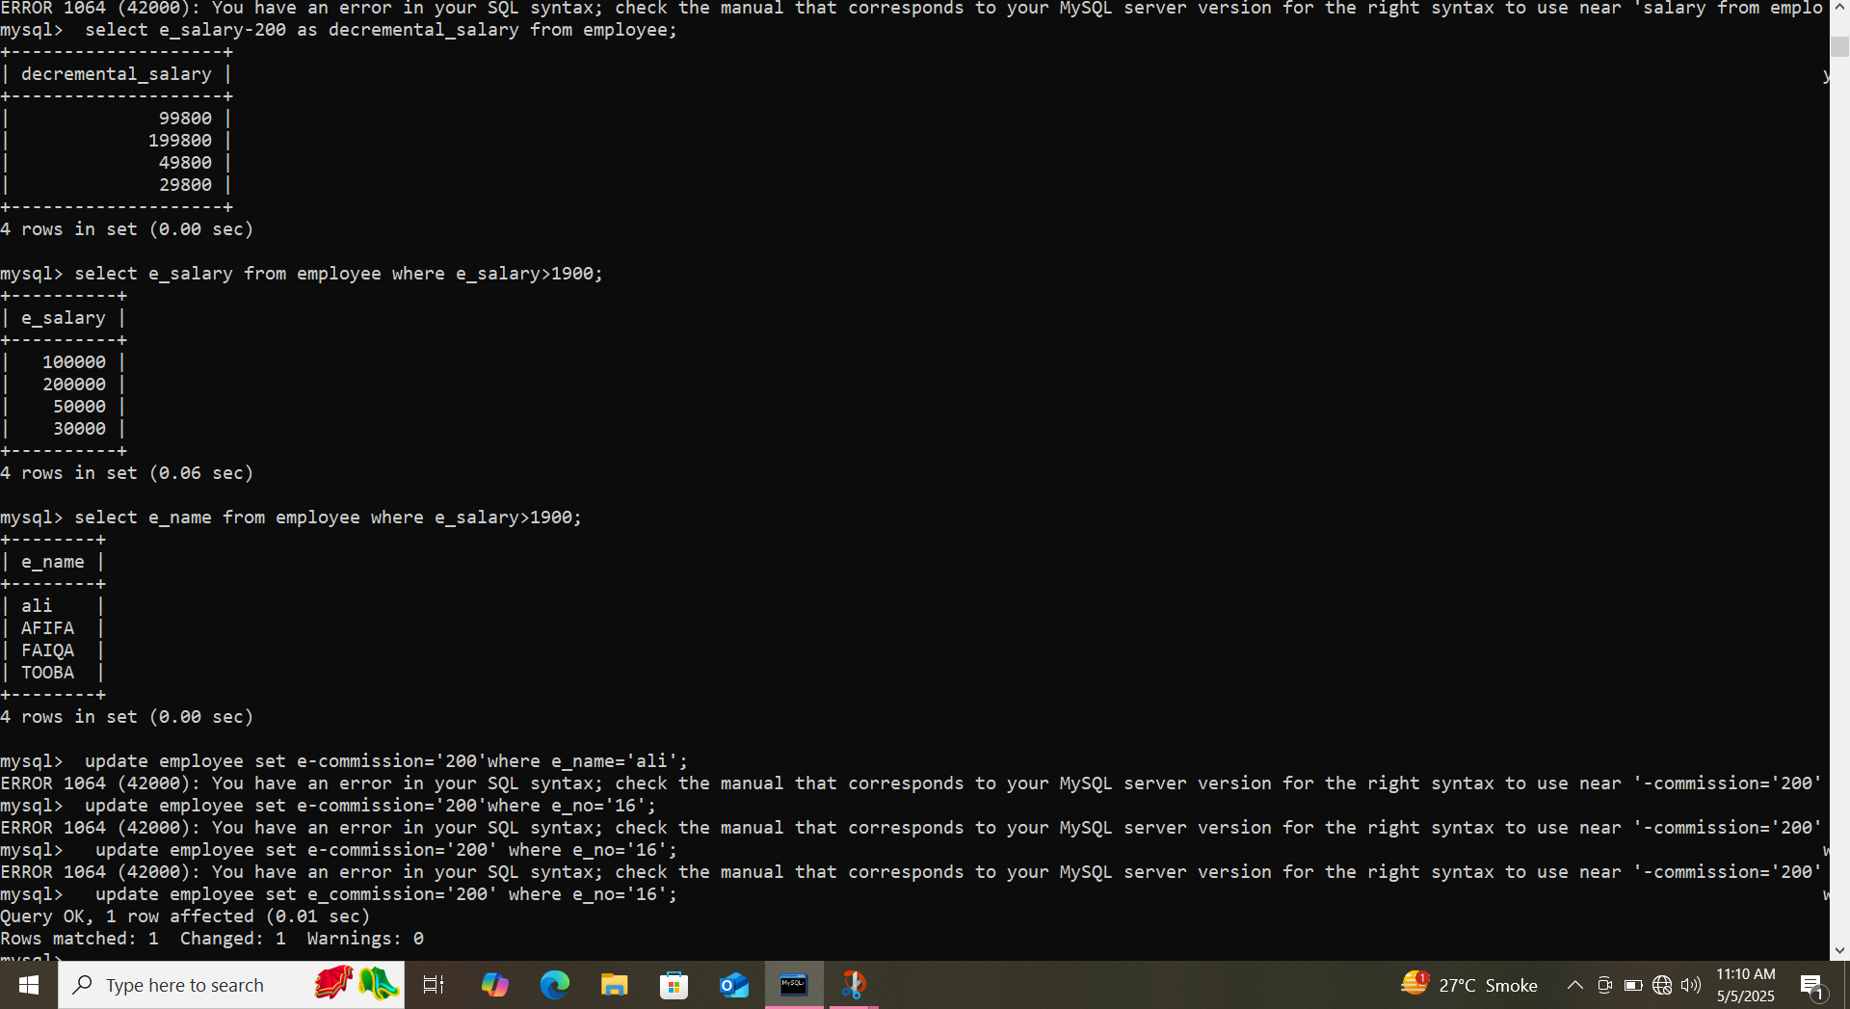

* APPLY QUERY ,in which salary is greater than 1900 but they give name of those who have salary greater than 1900



* Update e_commission in table employee:



* Select * from employee;



* Compare two tables:

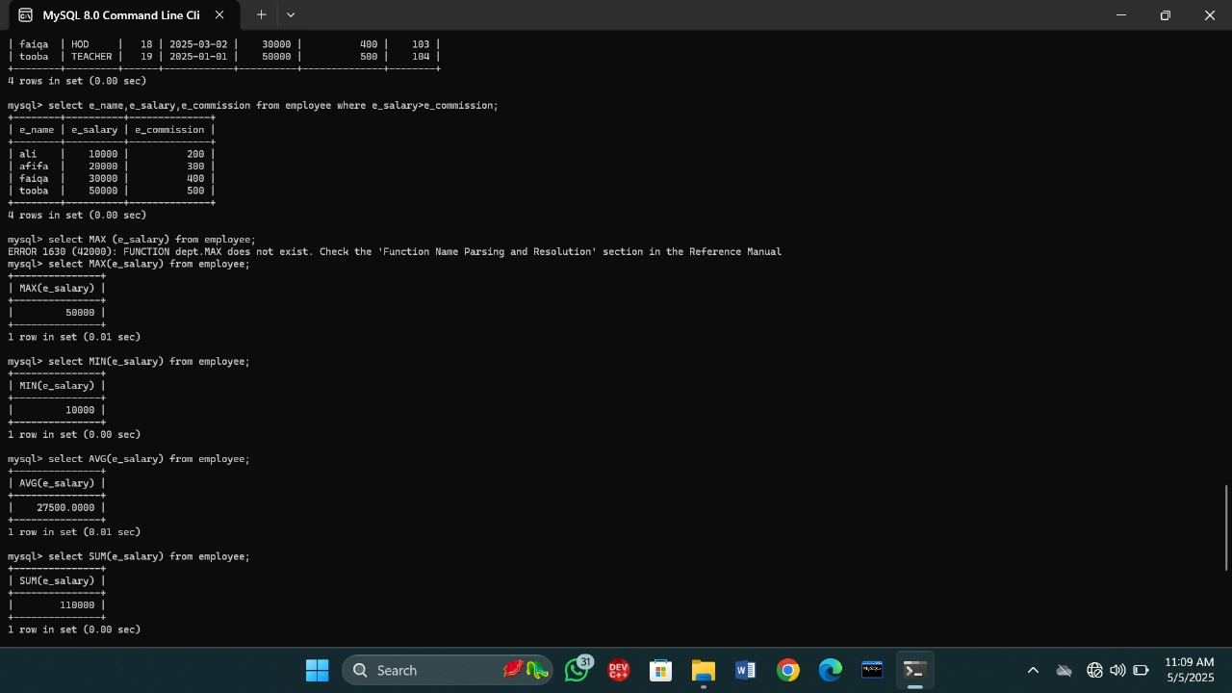

* Query of Maximum salary



* Query of minimum salary



* Query of AVERAGE salary



* Query of sum of all the salaries



* Query of selecting grade_no from grade as scale



* Query of distinct e_name from employee

